

Impact of Female Mating Status on Male Courtship Behaviour in the Sexually Cannibalistic New Zealand Fishing Spider *Dolomedes minor* (Araneae, Pisauridae)

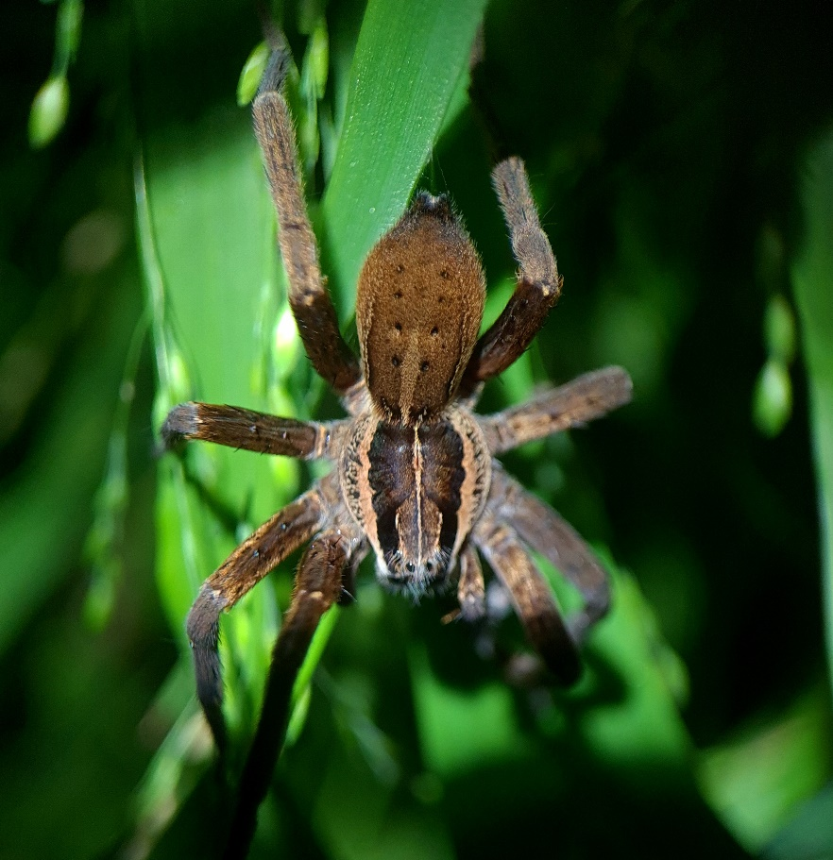

Master’s internship report by: Bastien Clémot

First-year Master of ‘Biodiversity Ecology Evolution

Functional Behavioural and Evolutive Ecology”

_

Delivered at Invertebrate Behavioural Ecology Lab, University of Waikato

Supervisor: Dr. Chrissie Painting

_

Conducted at Université de Rennes

Referent: Dr. Julien Pétillon

_

Internship from 06-04-2023 to 23-06-2023

Submitted on 09-06-2023

Supported on 21-06-202

**ACKNOWLEDGEMENTS**

I would like to express my deepest gratitude to my supervisor **Chrissie Painting** for allowing me to make this marvellous internship in New Zealand, for being an incredible supervisor, both trusting in my abilities and giving me her invaluable advice and experience, and for imbuing me her passion for spiders and honourably her enjoyment for feijoas.

I would also like to extend my gratitude to **Simon Connolly** for teaching me everything about *Dolomedes* fieldwork and rearing in the lab, for sharing with me his precious data and videos on *Dolomedes minor* mating, for accompanying me in my desperate seek for *Dolomedes dondalei* and for being a nerd mate and inviting me to play Dungeons&Dragons.

My work here wouldn’t have been possible without the help of **Bruce Patty**, who coached me on safety measures in the field and the laboratory, and always was here to help me whenever I needed or struggled with something, notably when I couldn’t feed my spiders when my magnetic card wasn’t working.

I would also like to thank my university referent, **Julien Pétillon**, who answered all of my questions and my insecurities about my work with unparalleled rapidity and patience.

Many thanks to **Estela Folch Chaos** for being here to advise me on how to survive as a lost European among Kiwis, and for the smelly and chaotic fieldwork we had at Rotorua.

I cannot leave the Invertebrate Behavioural Ecology Lab without expressing my sincere gratitude to all the lab team, for all of these incredible lab meetings spend with you and the friendly framework you provided, discussing about everything exciting scientific subjects to our difficulties and insecurities in science.

Special thanks to **Marijke Strujik** and **Kamolphat Atsawawaranunt** for lending me their house at the beginning of my stay in New Zealand, for sharing nice moments with me and having fun at the climbing gym, and for pardoning me to have scratched the wheel of their car.

Finally, nobody has been more important to me in this project than my family and my friends, even 18,000 km away from me. I’m thanking **Simon Boisteau**, **Laura Borner**, **Raphaëlle Lebailly**, **Jamy Ragnaud**, **Pierre-Alexandre Quittet,** **Lena Deck** and so many others for giving me their invaluable support every day, especially when I was chasing my spiders in the lab and working probably far too late at night on this report.

**INTRODUCTION**

Male courtship evolution is historically considered to be driven by female mate selection, but may also be dependent on male investment decisions in sexually cannibalistic species. Reproductive success relies on various secondary sexual traits and pre-copulatory courtship behaviours, which exhibit high diversity across animal taxa (Quigley & Fusani, 2018). These traits cover a wide range of sensory modalities. For example, salamanders showcase visual ornament patterns (Ancillotto *et al.*, 2022), eared moths engage in ultrasound communication (Nakano *et al*., 2015), songbirds perform duet dancing (Soma *et al*., 2019), and cockroaches involve chemical and gustatory senses during mating (Wada-Katsumata *et al.*, 2023).

The evolution of courtship traits is commonly attributed to sexual selection, where individuals choose their partner based on their potential to enhance reproductive success (Andersson & Iwasa, 1996). Consequently, traits that are energetically costly to display or lead to reduced survival are often selected as indicators of an individual’s quality (Zahavi, 1974). This system supports the existence of extreme courtship traits, such as exaggerated nuchal humps in cichlid fishes (Rometsch *et al.*, 2021). Therefore, individuals subject to sexual selection often undergo fitness trade-offs by developing costly courtship traits to ensure reproductive success and increase their chances of mating (Brommer, 2007).

Costly courtship traits are commonly displayed by males in various taxa, while females carry out mate selection (Quigley & Fusani, 2018). This aligns with the classical concept of anisogamy, where females are typically constrained by the number of gametes they produce and the high energetic cost associated with reproduction, while males are less limited by gamete number and tend to maximise their reproductive success by increasing their number of mating partners (Bateman, 1948; Darwin, 1981). However, recent studies have highlighted the great complexity and diversity of mating systems and sexual selection, with the implication of male parental care in cichlid fish sexual dimorphism, for example (Ronco *et al*., 2019).

Although males engage in courtship behaviours to enhance their chances of mating, they may also have the ability to adjust their level of investment in reproductive effort, based on the quality and mating status of the female (Briceño and Eberhard, 2002; Engqvist, 2009). This phenomenon has been investigated in various Arthropod species, where males can modify the quantity and quality of sperm they ejaculate depending on the female mating status (Thomas & Simmons, 2007; Wedell *et al*., 2002). In such cases, mating with an already mated female can lead to a decrease in fitness due to sperm competition with other males, reduced likelihood of paternity and the energetic cost of sperm production, which makes male courtship behaviours and trade-offs also dependent on the female quality (Thomas & Simmons, 2007).

Within this context, the study of spider taxa is especially relevant to the understanding of rare and particular reproductive behaviours and mating mechanisms, such as cases of extreme sexual dimorphism (Cordellier *et al.*, 2020) or sexual cannibalism by females (Buskirk *et al*., 1982). In the same way, spiders also exhibit a wide range of courtship behaviours and sensory modalities. For instance, peacock spiders employ dances and visual cues (Girard *et al.*, 2015), wolf spiders use vibrational communication (Chiarle *et al*., 2013) and gift-giving spiders display nuptial food gifts (Prokop & Okrouhlík, 2021). The prevalence of sexual cannibalism and female aggression in many spider species introduces a new constraint on male mating choice, as it restricts males in terms of the number of mating they can engage in, sometimes even to a single one in species with obligatory mate consumption (Elgar, 1992; Knoflach & Van Harten, 2010). Consequently, male spiders face limitations on their reproductive opportunities, leading to the necessity of carefully choosing mates based on female quality.

This importance of male choice has been demonstrated in sexually cannibalistic species, such as orb-web spiders, where unmated males preferentially mated with unmated females (Gaskett *et al*., 2004) or evaluate female quality through chemical cues before copulation (Cory & Schneider, 2020). In addition to adjusting their courtship traits for mate selection, males must also minimize the risks of being killed by the female. This can involve adapting reproductive timing, as observed in Mediterranean tarantulas (Moya-Laraño *et al*., 2004), or utilising chemical, vibrational, and contact assessment and communication strategies, as seen in funnel-web spiders (Xiao *et al*., 2015). As a result, males face a trade-off in their courtship investment, balancing the risk of cannibalisation against the quality of potential mates, thereby driving the mating systems in many spider species (Schneider & Elgar, 2001; Persons & Uetz, 2005).

The New Zealand nursery web spider, *Dolomedes minor*, belongs to the Pisauridae family, in which studies have already described the reproductive and courtship system of several model species such as *Pisaura mirabilis* (Eberhard *et al.*, 2020; Stålhandske, 2001). The mating systems of several *Dolomedes* spiders have also been investigated, particularly concerning sexual cannibalism in species like *D. triton* (Johnson & Sih, 2005; Zimmermann & Spence, 1989), *D. tenebrosus* (Schwartz *et al*., 2014) and *D. fimbriatus* (Fisher & Price, 2019). Additionally, studies have explored the significance of vibrational signals in their predation behaviour (Bleckmann & Lotz, 1987) and courtship behaviour (Arnqvist, 1992). However, little is known about *D. minor* species, with only brief descriptions available regarding its habitat preferences for near-water vegetation habitats (Vink & Dupérré, 2010) and the occurrence of sexual cannibalism (unpublished data).

This Master's internship aims to investigate whether males of *D. minor* adjust their courtship behaviour based on the female mating status. The primary goals of this study are to determine if *D. minor* males engage in ritualized courtship routine, investigate whether courtship behaviour is influenced by female mating status, and assess the potential impact of these courtship adjustments on mating outcomes. It is hypothesized that *D. minor* males will exhibit elaborate and costly courtship patterns and behaviours during interactions with females. Additionally, it is predicted that when encountering an already mated female, males will display shorter courtship behaviours but with distinct courtship structures. This may involve intensifying specific communication signals as a strategic allocation of energy, spending less time on a mated female while increasing their chances of survival. Furthermore, it is anticipated that courtship interactions between males and mated females will result in fewer copulation opportunities but will provide a safer interaction for the male, with fewer aggressive attacks from the female. To achieve these objectives, mating experiments will be conducted in a laboratory setting using both unmated and already mated *D. minor* females. Courtship behaviours exhibited by males during the trials will be described and scored to provide a first complete ethogram of *D. minor* reproductive behaviours. This ethogram will serve to compare courtship investment and communication between the two groups. Sequential analysis will be employed to compare the duration and structure of courtship behaviours. Finally, the outcomes of the mating trials will be compared between the female mating status.

**MATERIAL AND METHODS**

**Spider collection and maintenance**

All *D. minor* individuals were collected in the field by Simon J. Connolly as part of his PhD research. A total of 393 individuals were gathered in several near-water habitats at Ashley Gorge, Port Hills and Eyre River in the Canterbury regions and the campus of the University of Waikato, Hammond Park and Braithwaite Park in the city of Hamilton (New Zealand). The collection of individuals was performed between 21-09-2020 and 24-04-2021, corresponding to the summer season and the spider’s primary period of activity. Fieldwork was conducted exclusively at night, as individuals were more active and easily located with a head torch, due to the light reflection of their eyes. All collected individuals were brought back to the Invertebrate Behavioural Ecology Lab (Waikato University, Hamilton, New Zealand) where their developmental state was assessed. Only juvenile and penultimate (*i.e.* one moult from maturity) males and females were kept for mating experiments to ensure that all individuals had not already mated before being collected. Spiders were then individually raised to maturity in 150 mm x 95 mm x 60 mm plastic containers with access to a wet cotton and a piece of egg carton as an enrichment device. Individuals were fed twice weekly with live crickets and plastic containers were cleaned out weekly to prevent mould formation and waste accumulation.

**Mating experiments**

Laboratory mating experiments between mature individuals were performed by Simon J. Connolly between 17-03-2021 and 08-08-2021. Trials were conducted in 265 mm x 235 mm x 120 mm plastic containers with a mesh roof and wall on one side to serve as climbing support. Females were all fed the day before the experiment to control for the impact of hunger on their aggressiveness, and individuals were weighed before or after the experiment to assess their weight during mating. Females were introduced first in the mating arena and males were introduced 10 minutes later to allow the female to acclimatize to the arena. Mating trials were recorded for 4 hours or until the clear end of interaction (*i.e.* cannibalisation by the female confirmed or male leaving after copulation), with digital cameras (Sony FDRAX53 4K).

For my study, I selected videos of 30 mating trials, involving 15 females and 27 different males. Selected trials were chronologically separated into two different groups. Fifteen of these trials were conducted between 15 different unmated females and 15 different unmated males, randomly paired, and were selected for analysis as courtship and copulation both occurred at least once during the trial. Trials of the second group were performed using the same 15 females (no longer unmated as a consequence) and 13 different males, and were selected as courtship occurred at least once during the trial. In this second group, two males were used twice and another one was reused from the first group, but with a different female.

**Courtship behaviour description**

All mating trials were initially scored by Simon J. Connolly for use in a different project, with BORIS Software. Courtship attempt was considered to start when a clear communication behaviour was performed toward the female, and was considered to end when the male retreated or stopped all communication behaviours to freely move in the arena. Therefore, the number of courtship attempts from the males and the number of female attacks were recorded for each trial. Also, the duration of each courtship attempts as well as the latency to first attack from the female, mount and copulation, were all timed for each trial.

In my study, I extend these initial measurements made by Simon J. Connolly, by re-scoring each trial video to describe the fine-scale courtship elements of *D. minor* males. Videos were randomly and blindly sampled between the two groups to prevent any observer bias. All trials were initially screened to compile a list of relevant and clearly identifiable behaviours and give them precise descriptions and names. Then, for each video, the first sequence of mounting of the male on the female, as well as the courtship attempt that precedes it, were watched at 0.5x speed to score all observed courtship elements. Courtship elements were considered non-exclusive as they could be performed simultaneously and were grouped into categories based on the body part used by the male.

**Statistical analyses**

All statistical analyses were performed with R software and figures were made using the package ‘ggplot2’. To analyse the impact of female mating status on the duration of male courtship behaviour, I performed Wilcoxon mean comparison tests for paired values on the total courtship duration, the number of courtship attempts and the mean duration of these attempts, between the two groups. Also, as these data were paired and non-normally distributed, I performed a jack-knife test to compare for homogeneity of variance between the two female mating status (Rothstein & Bell, 1981). As the number of attacks by the female directly influenced the number of courtships, I decided to monitor its influence. To do so, I performed generalised linear mixed model analyses with female identification number as a random factor, to assess the influence of the number of attacks from the female and her mating status on the total courtship duration, the number of courtship attempts and the mean duration of courtship attempts respectively.

To compare the impact of female mating status on the fine-scale structure of courtship behaviours, I used the ‘igraph’ network R package to produce networks of transitions between courtship elements for each group. With the behavioural sequences exported from BORIS software, I grouped all behaviours that were recorded simultaneously, as new combined behaviours. I removed all behaviours that had a duration of less than one second as I considered them to be artefacts linked to the inaccuracy of my observations. Then, I compiled the behavioural sequences previously scored and used the ‘igraph’ network analysis R package to compute for each group an observed matrix of behavioural transition frequency, where each cell corresponded to the number of occurring transitions from the behaviour in row to the behaviour in column. For each group, I then repeatedly and randomly permuted all behaviours within the behavioural sequences until obtaining 10,000 new matrixes of randomly generated behavioural transitions. These matrixes gave each transition of each group their expected distribution if behaviours were randomly distributed along behavioural sequences. I extracted the 95% quantile of each distribution and compared it with the first observed matrix of transitions. Observed behavioural transitions that had a frequency higher than the calculated 95% quantile were considered to occur more often than randomly and be significantly contributing to the overall structure of courtship behaviour. After keeping only significant behavioural transitions, I plotted the behavioural structure of courtship as networks for each of the groups to compare for structure differences (Bakeman *et al*., 1996; Green & Patek, 2018). Between the two groups, I compared the frequency of each behaviour and behavioural transition with Wilcoxon mean comparison tests for paired values.

Finally, in order to assess the influence of the male courtship behaviour on the mating outcomes, I used the total courtship duration, the number of courtship attempts and the mean duration of these attempts as explanatory variables on the latency to mount, to copulate and to the first attack, by performing generalised linear mixed model analyses with female identification number as a random factor. For analyses of count data (*i.e.* the number of courtship attempts), I used models with a Poisson distribution. Also, for models with multiple quantitative explanatory variables, I standardised them so they had a mean of zero and a standard deviation of one, to ensure that all of their estimated coefficients were on the same scale. For each analysis, I checked for possible collinearity between variables by calculating Variance Inflation Factors (VIF) and chose the most parsimonious models by comparing Akaike Information Criteria (AIC) between models. I also performed ANOVAs to assess which explanatory variables had a significant influence. All generalised linear mixed models were computed using the ‘lme4’ R package and ANOVAs with the ‘car’ R package.

**RESULTS**

**Influence of female mating status on male courtship duration**

Between mating trials with unmated and mated females, there were no significant differences in the total courtship duration (V = 86; P = 0,15), the number of courtship attempts (V = 20,5; P = 0,16) and the mean duration of courtship attempts (V = 92; P = 0,07) (Fig. 1). Likewise, there were no significant differences in variance for the total courtship duration (Z = -1,61; P = 0,06) and the mean duration of courtship attempts (Z = -0,61; P = 0,27). However, the number of courtship attempts had a significantly higher variance for the mating trials with mated females (Z = -3,84; P < 0,01), with a maximum number or attempts of 11, compared to 5 for the trials with unmated final, and a minimum of 1 attempt, compared to 2 for the unmated females group (Fig. 1b).

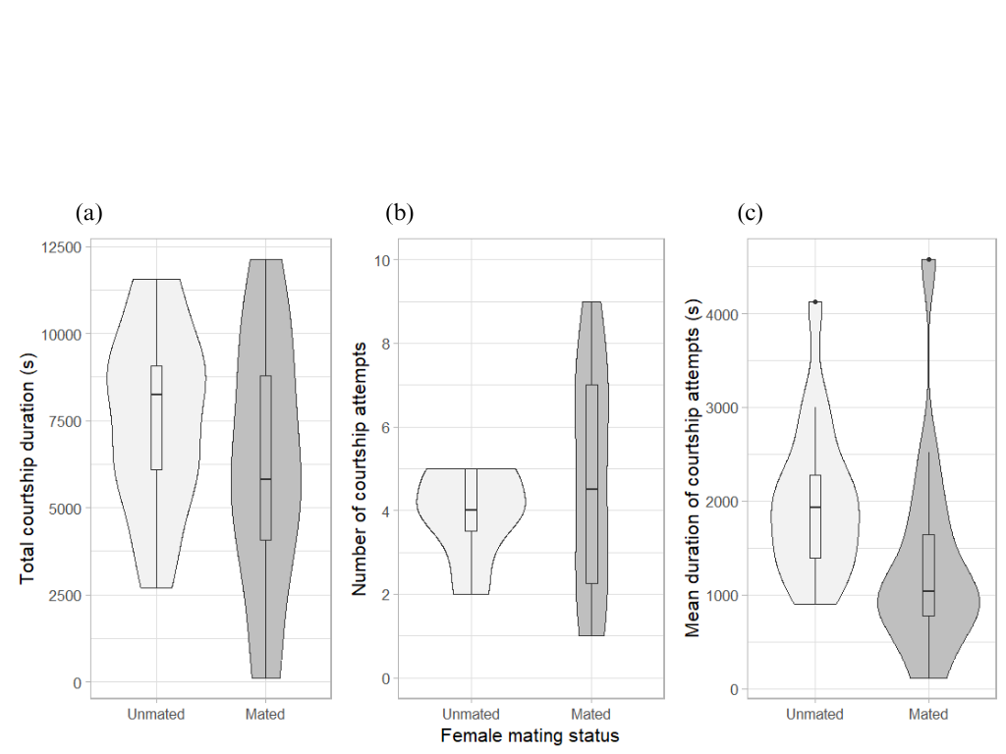

**Figure 1.** Comparison of male courtship duration parameters in *Dolomedes minor* between trials with unmated (n = 15) and already mated female (n = 15), with (a) total courtship duration, (b) number of courtship attempts and (c) mean duration of courtship attempts. Plots represent the density distribution of the variable as well as the median and the interquartile and 1.5x interquartile range. There was no significant mean difference for any of those parameters. Variance in the number of courtship segments was the only significantly different between the two groups.

Generalised linear mixed model analyses have confirmed that the female mating status had no significant impact on the total courtship duration (χ² = 1,79; df = 1; P = 0,18) and the mean duration of courtship attempts (χ² = 3,42; df = 1; P = 0,06). Similarly, the number of attacks from the female had no impact on the total courtship duration (χ² = 0,59; df = 1; P = 0,44) and the mean duration of courtship attempts (χ² = 0,83; df = 1; P = 0,36). However, for the number of courtship attempts, the number of attacks from the female was the only explanatory variable retained by the analysis of parsimony and was shown to have a positive effect (β = 0,06; se = 0,02; Z = 3,15; P < 0,01).

**Influence of female mating status on male courtship structure**

When presented to a female, *D. minor* males exhibited specific behaviours and patterns with their body parts. Scoring of fine-scale courtship elements has led to the description of 14 distinct elements including leg, pedipalp and abdominal motions performed in the air or by contacting the substrate. Motions performed with legs had an important diversity, with a total of 6 different elements described (Tab. 1). These leg motions were often exhibited simultaneously and independently between each leg and were sometimes performed by grabbing the female silk dragline with the tarsus.

**Table 1.** Ethogram of male courtship behaviours in *Dolomedes minor*.

|  |  |  |  |
| --- | --- | --- | --- |
|  |  | **Behaviour** | **Description** |
|  |  |  |  |
| Leg Display |  | Leg Raise | Raising of one or more of the legs, straight or slightly bent, for at least one second without performing any specific aerial pattern with the tarsus. Behaviour ends when the leg is lowered and touches the substrate or a specific vibrational pattern is drawn with the tarsus or the whole leg (See Wave and Aerial Tremulation). |
|  | Wave | Raising of one or more of the legs, straight or slightly bent, performing several circular or vertical fluid aerial movements with the whole leg and tarsus. Behaviour ends when the leg has stopped moving for more than one second (see Leg Raise) or is lowered to touch the substrate. |
|  | Aerial Tremulation | Raising of one more of the front legs, slightly bent, performing quick and repeated vertical movements, freely in the air or by grabbing a female silk dragline. Behaviour ends when the leg has stopped moving for more than one second (see Leg Raise) or is lowered to touch the substrate. |
|  | Wipe | Following Leg Raise, Wave or Aerial Tremulation behaviours, instead of simply touching the substrate, the individual is wiping the substrate with its tarsus, always toward its cephalothorax. |
|  | Quick Tapping | Extension forward of one or more of the front legs with a quick tapping on the substrate, sometimes performed on female legs when the male is close to a mounting attempt. |
|  | Leg Rubbing | While mounting the female, legs are bent and perform quick vertical and horizontal repeated movements. Often associated with a repositioning of the male on the female and approaching of the pedipalps toward the female genitalia. |
|  |  | Pedipalp Display | Quick vertical and repeated movement of both pedipalps in the air, sometimes while grabbing a female silk dragline. |
|  |  | Body Surge | Sudden tap of the abdomen on the substrate with contraction of the whole body. Often paired with an abrupt tap of some of the legs on the substrate, especially when they are already raised. |
|  |  | Abdominal Tremulation | Repeated quick horizontal vibration of the abdomen without touching the substrate. |
|  |  | Grooming | Brushing of the pedipalps, legs and chelicerae together, sometimes only two of them. |
|  |  | Approach | Locomotion toward the female accompanied by clear courtship signals. |
|  |  | Retreat | Quick moving away from the female in response to a clear signal from her such as a vibration, a movement or an attack. Behaviour can be triggered when the male is mounting the female, always leading to the end of Mount behaviour. |
|  |  | Mount | Male climbs onto the female’s abdomen. |
|  |  | Pedipalp Insertion | Extension of one pedipalp toward the genitalia of the female which leads to embolus insertion and successful copulation. |

A total of 15 mating trials with unmated females and 10 mating trials with already mated females were scored for the analysis of courtship structure. In both groups, a total of 14 behaviours and 32 significant transitions were mapped (Fig. 2). For accuracy, all leg motions were grouped as ‘Leg Display’ (Tab. 1) and the ‘Abdominal Tremulation’ behaviour wasn’t included in the scoring, as male’s position often made it impossible to observe.

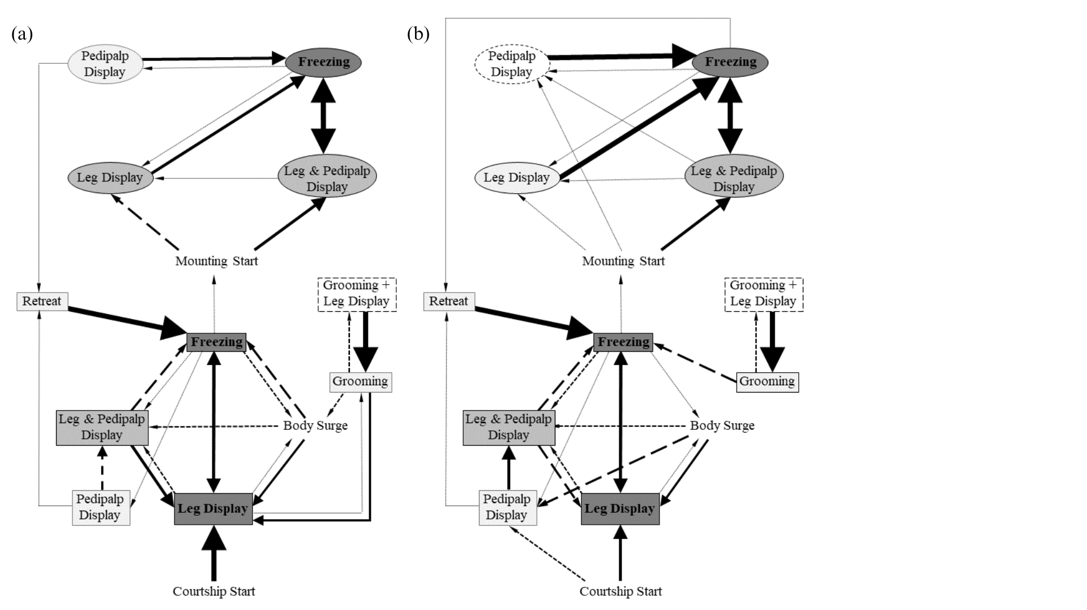

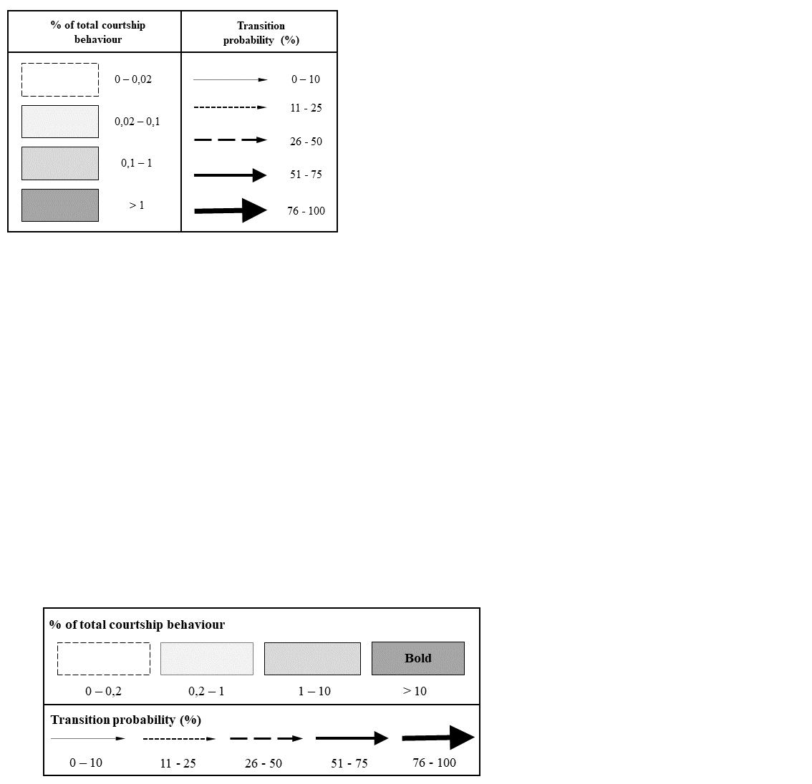

**Figure 2.** Sequential analysis of *Dolomedes minor* male courtship behaviour exhibited during mating with (a) unmated females (n = 15) and (b) already mated females (n = 10). Only behavioural transitions that were significant of the courtship structure were represented. Circles represent behaviours exhibited by males during their first mounting on the female, whereas rectangles represent behaviours exhibited during the last approach attempt before mounting.

Male behavioural sequences in both groups were mainly structured around two phases. After the start of courtship, *D. minor* males were first approaching the female while alternating between ‘Freezing’ and varied body motions. In both groups, ‘Freezing’ and ‘Leg Display’ were the most frequent behaviours in this phase and also had strong mutual transitions. However, the significative structure of the courtship behaviour hasn’t shown any specific sequences in the body motions that could specifically lead to female acceptance. Grooming behaviours were sometimes performed during this phase, but not in the second one. Eventually, the male approach led to a mounting attempt. During this second phase, ‘Freezing’ and ‘Leg & Pedipalp Display’ were the most frequent behaviour in both groups and once again showed strong mutual transitions. Similarly, the significative structure of courtship hasn’t shown any specific links between body motions that could lead to copulation or female attack. In both groups, ‘Retreat’ behaviour occurred in both phases and always led to ‘Freezing’ and the start of a new approach phase. At the end of courtship or copulation. Finally, there were no significant differences between any of the behaviour frequency and behavioural transition probabilities between the two, except for the ‘Leg Display’ behaviour when mounted, which was more frequent in mating trials with unmated females (V = 33; P = 0,04) (Fig. 2).

**Influence of male courtship on mating outcomes**

Generalised linear mixed model analyses haven’t shown any influence of the total courtship duration, the number of courtship attempts and the mean duration of courtship attempts on the latency to mount, to first attack by the female and to copulate, respectively (Tab. 2).

**Table 2.** Generalised linear mixed model analyses results between courtship duration parameters as explanatory variables and courtship outcomes parameters as response variables. Models were retained by calculating Variance Inflation Factors (VIF) and Akaike Information Criteria (AIC). Analyses haven’t shown any influence from the explanatory variables on the response variables.

|  |  |  |  |  |  |
| --- | --- | --- | --- | --- | --- |
|  |  |  | Response variables | | |
|  |  |  | Latency to mount | Latency to attack | Latency to copulate |
|  |  |  |  |  |  |
| Explanatory variables | Total courtship duration |  | χ² = 0,75; df = 1;  P = 0,39 | χ² = 0,77; df = 1;  P = 0,38 | χ² = 0,29; df = 1;  P = 0,59 |
| Number of courtship attempts |  | χ² = 0,08; df = 1;  P = 0,77 | χ² = 2,65; df = 1;  P = 0,10 | χ² = 0,05; df = 1;  P = 0,82 |
| Mean duration of courtship attempts |  | χ² = 0,94; df = 1;  P = 0,33 | χ² = 1,52; df = 1;  P = 0,22 | χ² = 0,29; df = 1;  P = 0,59 |

**DISCUSSION**

This study revealed that *D. minor* males displayed a ritualised courtship behaviour upon encountering a female. Their courtship included various pre-copulatory body movements and occasionally grabbing of the female silk dragline. Surprisingly, the duration of courtship and the outcomes of mating attempts were not found to be dependent on the female mating status. Similarly, the overall structure of courtship behaviour remained largely unchanged between the two mating groups. However, there was a wider range of courtship attempts by males in trials with previously mated females, and the number of male courtship attempts was positively influenced by the number of attacks from the female.

**Male ritualised courtship and communication cues**

When introduced to females, male *D. minor* spiders displayed a range of courtship behaviours, including an important variety of mechanical communication cues, such as leg and pedipalp waving, as well as tapping on the substrate. These behaviours were observed throughout the male’s approach and during the mounting process. Such behaviours, which heavily rely on motor performances, likely impose an energetic cost on the male to be maintained during the whole courtship (Clark, 2012). Similar courtship costs have been documented in various animal species, including spiders, and are known to depend on the male’s condition and energy allocation ability (Byers *et al*., 2010; Hoefler *et al*., 2008). Additionally, males exhibited a retreat response when faced with female aggression, suggesting their aversion to female aggressiveness and their attempt to avoid pre-copulatory cannibalism. These findings confirm that male *D. minor* spiders engage in a ritualized pre-copulatory courtship behaviour with the behavioural requirements that may result in an evolutionary compromise. In their courtship, males may experience an energetic cost associated with female acceptance while simultaneously trying to evade sexual cannibalism.

The presence of vibrational and visual cues in courtship behaviour is a common characteristic among Lycosid and Pisaurid spiders (Eberhard *et al*., 2020; Gibson & Uetz, 2008; Hoefler *et al*., 2008). Previous studies on *D. triton*, *D. fimbriatus* and *D. scribens* have already documented the occurrence of vibrational and visual cues during courtship, including abdominal vibrations, leg movements, and the following of female silk draglines (Arnqvist, 1992; Kaston, 1936; Roland & Rovner, 1893). These previous documentations align with the description of *D. minor* courtship presented in this study.

The role of vibrational communication cues emitted by male spiders during courtship has been extensively investigated, particularly in web-building spiders where vibrations are transmitted through the female’s web (Vibert *et al.*, 2016). Many studies have focused on describing these signals and their effects, including stimulating receptive females to mate, which could differ depending on female mating status, as well as reducing the risk of cannibalism (Maklakov *et al*., 2003; Sivalinghem & Mason, 2020; Wignall & Herberstein, 2013). While Lycosid and Pisaurid spiders do not build traditional webs, the females do produce silk draglines that have been observed to be followed while emitting vibrational communication cues in Lycosid males (Gibson & Uetz, 2008; Tietjen & Rovner, 1980). Similar silk-following behaviours have been described in Pisaurid spiders, and the importance of vibrational sensitivity has been demonstrated in their reproductive behaviour, enabling females to distinguish conspecific males from prey (Arnqvist, 1992; Barth, 1985; Bleckmann & Barth, 1984; Bleckmann & Bender, 1987). These studies provide support for the idea that male spiders may make investment decisions in their vibrational communication behaviour to minimize the risk of cannibalism and enhance female acceptance.

However, it is important to note that the description provided in this study may have overlooked several aspects of *D. minor* courtship. *Dolomedes* species are semi-aquatic spiders capable of moving on the water surface, and their reproduction often occurs near water bodies (Suter *et al*., 1997). Vibrational communication through waves emitted on the water surfaces has been found to be crucial in the reproductive behaviour of other Arthropod species, such as water strides (Gerridae) (Wilcox, 1972). In *Dolomedes* spiders, numerous studies have demonstrated that wave production on the water surface plays a significant role in intersexual communication and may vary between species (Arnqvist, 1992; Bleckmann & Bender, 1987; Roland & Rovner, 1983). However, the mating arena used in this study did not include water, which could have impacted courtship behaviour by limiting the perception of vibrations between individuals and thereby not being considered in this study. Additionally, the frequency of these vibrations, which studies have shown to be relevant in communication within this spider family, was not investigated here (Eberhard *et al.,* 2020). Finally, previous studies on *Dolomedes* courtship behaviours have described the involvement of tactile communication between the sexes in courtship, which was not included in this study as the courtship description focused solely on male behaviour (Arnqvist, 1992; Roland & Rovner, 1983).

**Adaptative courtship behaviour depending on female mating status**

These results have demonstrated that the duration of courtship in *D. minor* was not influenced by the female mating status. Furthermore, apart from a reduced frequency of leg display behaviours during mounting when the female was already mated, the female mating status did not impact the overall structure of male courtship behaviour. Consequently, these findings indicate that, within the investigated courtship parameters, *D. minor* males didn’t appear to adjust their courtship behaviour sequence based on female quality. Additionally, the duration of courtship and the number of male attempts were not correlated with copulation opportunities or female aggressiveness, suggesting that male time allocation was not relevant to the mating outcomes in this species.

The influence of female mating status on male mate choice through courtship behaviour has been studied in various spider species. For example, in funnel web spiders (Atracidae), males have been shown to prefer unmated females and exhibit different courtship behaviours (Riechert & Singer, 1995). Similarly, Lycosid spiders have been found to employ different mating strategies depending on the female mating status, with shorter mounting latency when the female was already mated (Bunch & Wilgers, 2011). Therefore, the lack of an effect of female mating status found in the results of this study was unexpected.

However, in these previous studies and other reviews, it has been suggested that male spiders use chemical cues emitted by females to assess their mating status, with the potential transfer of male substances to unmated female when mating, to deter sperm competition from other males (Rypstra *et al*., 2003; Thomas, 2011). In *Dolomedes* spiders, Roland & Rovner (1983) investigated the production of chemical compounds by the female that triggers male courtship behaviour. This compound was found to be released on the female silk dragline and the water’s surface, rather than in the air. They also observed that the courtship response of *D. triton* males was stronger when the female had been in contact with water for a longer duration, which aligned with field observations of the species. In their experiment, females were kept in mating arenas with water for at least one hour, if not several days, whereas in this study, females were introduced in the mating arena for only 10 minutes before male introduction. Moreover, the mating arena used in their study was 3 times more voluminous than the ones used here. Therefore, it is possible that the courtship behaviour of *D. minor* males observed in this study was triggered by the presence of the female silk dragline or visual cues detected by the males, especially considering the smaller size of the arena. However, it should be expected that the absence of water and the shorter time given for the female to release pheromones could have affected the males’ ability to detect chemical indicators of female mating status.

Other studies have revealed that many spider species employ mating plugs, which are used by males to block the female’s genitalia and reduce sperm competition from other males (Uhl *et al.*, 2010). The occurrence of this behaviour has been documented in Pisaurid spiders of the *Tinus* genus, where broken emboli (*i.e.* part of the male copulatory bulb) were found in the female genitalia (Carico, 1976). In the *Dolomedes* genus, observations of genital mutilation have been made in *D. tenebrosus* (Schwartz *et al.*, 2013), and broken emboli have been observed in *D. minor* (unpublished data). These copulatory plugs represent a further disadvantage for males encountering an already mated female and are likely assessed by males upon contact with the female genitalia (Parker *et al.,* 1996; *Uhl et al.*, 2010). Therefore, it is plausible to hypothesise that *D. minor* males might take into account the potential presence of mating plus in the female genitalia and adjust their courtship behaviour accordingly. However, the courtship description provided in this study only covers the segment preceding the first mounting behaviour, which precludes the assessment of this potential impact.

In addition to modifications in courtship behaviour, it has been observed in other Arthropod taxa, such as crickets and Drosophilids, that males can adjust the quantity and quality of sperm ejaculated based on female mating status (Thomas & Simmons, 2007; Wedell *et al*., 2002). In spiders, attempts have been made to investigate sperm allocation in web-building spiders, but no significant results have been obtained thus far (Schneider *et al*, 2011). Nevertheless, this highlights the need for further investigation into other parameters beyond courtship behaviour in male mate choice and investment.

**Potential cues for a female mate choice driven mating system**

Finally, the results presented in this study demonstrated that the number of courtship attempts from the males exhibited a higher variability when females were already mated. This indicates that some males performed fewer attempts, while others significantly performed more compared to mating with unmated females. Additionally, the number of courtship attempts was found to be correlated with the frequency of female attacks. This suggests that males responded to female aggression by retreating and subsequently initiating a new courtship attempt. These findings lead to the assumption that among females that were already mated, there may be variations in their level of docility or aggressiveness toward males.

There is limited documentation on the impact of female mating status on their aggressiveness within the Pisauridae family. However, previous studies have indicated that mated females tend to attack and cannibalise males more frequently compared to unmated females (Johnson, 2001). Considering that male condition has been shown to influence female acceptance in Pisauridae (Eberhard *et al*., 2020), it is possible to hypothesize that mated females may assess the male’s condition during courtship and make a decision based on their previous mating experience, choosing to mate with a high-quality or resort to cannibalism as a foraging strategy. Nevertheless, this hypothesis remains subject to discussion, as other studies have suggested that female behaviour might not be influenced by the male’s adaptative value (Arnqvist & Henriksson, 1997; Johnson, 2001).

Overall, these intriguing results provide an opportunity for investigating the mating system of the *D. minor* species. The cannibalism of males by females was examined from both the female and male perspectives. From the female perspective, it could be associated with the loss of a mating opportunity, but also with gaining energy intake (Arnqvist & Henriksson, 1997; Johnson, 2001). From the male perspective, it was previously studied in *D. tenebrosus*, where males are monogynous, suggesting that self-sacrifice could be adaptative and intentionally enhance sexual cannibalism (Schwartz *et al.*, 2013). In *Dolomedes* spiders, both male monogyny and polygyny have been described and highly discussed (Schoenberg *et al.*, 2022; Schwartz *et al.*, 2013). Results provided in *D. minor* shown that males can mate multiple times and are thus polygynous, which opens up further avenues of investigating how the mating system of *D. minor* is influenced by strategies related to female aggressiveness, male courtship and reproductive decisions.

**CONCLUSION**

When encountering a female, *Dolomedes minor* males have been shown to engage in ritualised courtship behaviours with an important diversity of mechanical cues. This study provided the first complete description of male courtship behaviour, aligning with the previously documented vibrational and visual cues observed in Lycosid and Pisaurid. Surprisingly, the mating status of the females hasn’t been shown to affect the investment of males in courtship duration and structure. These findings provide a foundation for future investigations on male courtship behaviours in this species. It is hypothesized that vibrational frequency, chemical cues, physical contact between the individuals and the presence of water in their habitat, could influence male courtship decisions and assessment of female quality. Additionally, it is suggested that male assessment of female mating status may lead to adaptations beyond courtship modifications, such as changes in the quality and quantity of sperm ejaculated, notably in response to potential copulatory plugs. Furthermore, this study provides preliminary insights into the mating system and occurrence of sexual cannibalism in the *Dolomedes minor* species, creating a basis for further investigations to determine the driving factors behind the adaptative strategies employed by males and females during their reproduction.

**REFERENCES**

Ancillotto L., Vignoli L., Martino J., Paoletti C., Romano A., Bruni G. (2022). Sexual dichromatism and throat display in spectacled salamanders: a role in visual communication? Journal of Zoology, 318:75-83.

Andersson M., Iwasa Y. (1996) Sexual selection. Trends in Ecology & Evolution, 11(2):53-8.

Arnqvist G. (1992). Courtship behavior and sexual cannibalism in the semi-aquatic fishing spider, *Dolomedes fimbriatus* (Clerck) (Araneae: Pisauridae). The Journal of Arachnology, 20:222-226.

Arnqvist G., Henriksson S. (1997). Sexual cannibalism in the fishing spider and a model for the evolution of sexual cannibalism based on genetic constraints. Evolutionary Ecology, 11:255-273.

Barth F. G. (1985). Neuroethology of the Spider Vibration Sense. In Barth F. G. (1985) Neurobiology of Arachnids. Springer Berlin, Heidelberg.

Bakeman R., Robinson B. F., Quera V. (1996). Testing sequential association: Estimating exact p values using sampled permutations. Psychological Methods, 1:4-15.

Bateman A. J. (1948). Intra-Sexual Selection in Drosophila. Heredity, 2:349-368.

Bates D., Maechler M., Bolker B., Walker S. (2015). Fitting Linear Mixed-Effects Models Using lme4. Journal of Statistical Software, 67(1), 1-48.

Bleckmann H., Barth F. G. (1984). Sensory ecology of a semi-aquatic spider (*Dolomedes triton*). Behavioral Ecology and Sociobiology, 14:303-312.

Bleckmann H., Bender M. (1987). Water Surface Waves Generated by the Male Pisaurid Spider *Dolomedes triton* (Walckenaer) during Courtship Behavior. The Journal of Arachnology, 15:363-369.

Bleckmann H., Lotz T. (1987). The vertebrate-catching behaviour of the fishing spider *Dolomedes triton* (Araneae, Pisauridae). Animal Behaviour, 35:641-651.

Briceño R. D., Eberhard W. G. (2002). Decisions during courtship by male and female medflies (Diptera, Tephritidae): correlated changes in male behavior and female acceptance criteria in mass-reared flies. Florida Entomological Society, 85(1):14-31.

Brommer J. E. (2007). The evolution of fitness in life-history theory. Biological Reviews, 75:377-404.

Bunch S., Wilgers D. J. (2011). Female mating status affects male mating tactic expression in the wolf spider *Rabidosa punctulata*. Current Zoology, 68:121-127.

Buskirk R. E., Frohlich C., Ross K. G. (1982). The natural selection of sexual cannibalism. The American Naturalist, 123:612-625.

Byers J., Hebets E., Podos J. (2010). Female mate choices based upon male motor performance. Animal Behaviour, 79:771-778.

Carico, J. E. (1976). The spider genus *Tinus* (Pisauridae). Psyche, 83:63-78.

Chiarle A., Kronestedt T., Isaia M. (2013). Courtship behavior in European species of the genus *Pardosa* (Araneae, Lycosidae). The Journal of Arachnology 41:108-125.

Clark C. J. (2012). The role of power versus energy in courtship: what is the ‘energic cost’ of a courtship display? Animal Behaviour, 84:269-277.

Cordellier M., Schneider J. M., Uhl G., Posnien N. (2020) Sex differences in spiders: from phenotype to genomics. Development Genes and Evolution, 230:155-172.

Cory A., Schneider J. (2020). Males of sexually cannibalistic spider chemically assess relative female quality. BMC Evolutionary Biology 20:90.

Csardi G., Nepusz T. (2006). The igraph software package for complex network research. InterHournal, Complex Systems. URL: https://igraph.org.

Darwin C. (1981). The descent of man, and selection in relation to sex. Princeton University Press.

Eberhard M. J. B., Machnis A., Uhl G. (2020). Condition-dependent differences in male vibratory pre-copulatory and copulatory courtship in a nuptial gift-giving spider. Behavioral Ecology and Sociobiology, 74:138.

Elgar M. A. (1992). Sexual cannibalism in spiders and other invertebrates. In Elgar M. A., Crespi B. J. (1992) Cannibalism: Ecology and evolution among diverse taxa. Oxford University Press, pp128-155.

Erngqvist L. (2009). Should I stay or should I go? Condition- and status-dependent courtship decisions in the scorpionfly *Panorpa cognata*. Animal Behaviour, 78:491-497.

Fisher A. M., Price T. A. R. (2019). Density-dependent aggression, courtship, and sex ratio in a fishing spider. Arachnology 18:295-300.

Fox J., Weisberg S. (2019). An R Companion to Applied Regression, Third Edition. Thousand Oaks CA: Sage. URL: https://socialsciences.mcmaster.ca/jfox/Books/Companion/.

Friard O., Gamba M. (2016). BORIS: a free, versatile open-source event-logging software for video/audio coding and live observations. Methods in Ecology and Evolution, *7*:1325–1330.

Gaskett A. C., Herberstein M. E., Downes B. J., Elgar M. A. (2004). Changes in male mate choice in a sexually cannibalistic orb-web spider (Araneae: Araneidae). Behaviour, 141:1197-1210.

Gibson J. S., Uetz G. W. (2008). Seismic communication and mate choice in wolf spiders: components of male seismic signals and mating success. Animal Behaviour, 75:1253-1262.

Girard M. B., Elias D. O., Kasumovic M. M. (2015). Female preference for multi-modal courtship: multiple signals are important for male mating success in peacock spiders. Proceedings Royal Society B, 282:20152222.

Green P. A., Patek S. N. (2018). Mutual assessment during ritualized fighting in mantis shrimp (Stomatopoda). Proceeding Royal Society B, 285:20172542.

Hoefler C. D., Persons M. H., Rypstra A. L. (2008). Evolutionarily costly courtship displays in a wolf spider: a test of viability indicator theory. Behavioral Ecology, 19:974-979.

Johnson J. C. (2001). Sexual cannibalism in fishing spiders (*Dolomedes triton*): an evaluation of two explanations for female aggression towards potential mates. Animal Behaviour, 61:905-914.

Johnson J. C., Sih A. (2005). Precopulatory sexual cannibalism in fishing spiders (*Dolomedes triton*): a role for behavioral syndromes. Behavioral Ecology & Sociobiology, 58:390-396.

Kaston B. J. (1936). The senses involved in the courtship of some vagabond spiders. Entomologica Americana, 16:97-167.

Knoflach B., Van Harten A. (2010). Palpal loss, single palp copulation and obligatory mate consumption in *Tidarren cuneolatum* (Tullgren, 1910) (Araneae, Theridiidae). Journal of Natural History, 34:8, 1639-1659.

Maklakov A. A., Bilde T., Lubin Y. (2003). Vibratory courtship in a web-building spider: signalling quality or stimulating the female? Animal Behaviour, 66:623-630.

Moya-Laraño J., Pascual J., Wise D. H. (2004). Approach Strategy by which Male Mediterranean Tarantulas Adjust to the Cannibalist Behaviour of Females. Ethology 110:717-724.

Nakano R., Takanashi T., Surlykke A. (2015). Moth hearing and sound communication. Journal of Comparative Physiology A, 201:111-121.

Parker G. A., Ball M. A., Stockley P., Gage M. (1996). Sperm competition games: individual assessment of sperm competition intensity by group spawners. Proceedings of the Royal Society B, 263:1291-1297.

Persons M. H., Uetz G. W. (2005). Sexual cannibalism and mate choice decisions in wolf spiders: influence of male size and secondary sexual characters. Animal Behaviour, 69:83-94.

Prokop P., Okrouhlík J. (2021). Metabolic cost of holding nuptial food gifts for male spiders. Ecological Entomology, 46:684-690.

Quigley D., Fusani L. (2018). Courtship and Mating. In Skinner M. L. (2018) Encyclopedia of Reproduction (Second Edition), 6:67-71.

R Core Team (2022). R: A language and environment for statistical computing. R Foundation for Statistical Computing. Vienna, Austria. URL: https://www.R-project.org/.

Riechert S. E., Singer F. D. (1995). Investigation of potential male mate choice in a monogamous spider. Animal Behaviour, 49:715-723.

Roland C., Rovner J. S. (1983). Chemical and vibratory communication in the aquatic Pisaurid spider *Dolomedes triton*. Journal of Arachnology, 11:77-85.

Rometsch S. J., Torres-Dowdall J., Machado-Schiaffino G., Karagic N., Meyer A. (2021). Dual function and associated costs of a highly exaggerated trait in a cichlid fish. Ecology and Evolution, 11:17496-17508.

Ronco F., Roesti M., Salzburger W. (2019). A functional trade-off between trophic adaptation and parental care predicts sexual dimorphism in cichlid fish. Proceedings Royal Society B, 286:20191050.

Rothstein S. M., Bell W. D. (1981). A jackknife test of homogeneity of variance with paired replicates data. Psychometrika, 46:1.

Rypstra A. L, Wieg C., Walker S. E., Persons M. H. (2003). Mutual Mate Assessment in Wolf Spiders: Differences in the Cues Used by Males and Females. Ethology, 109:315-325.

Schneider J. M., Elgar M. A. (2001). Sexual cannibalism and sperm competition in the golden orb-web spider *Nephila plumipes* (Araneoidea): female and male perspectives. Behavioral Ecology, 12:547-552.

Schneider J. M., Lucass C., Brandler W., Fromhage L. (2011). Spider Males Adjust Mate Choice but Not Sperm Allocation to Cues of a Rival. Ethology, 117:970-978.

Schoenberg D., Hebets E. A., Sullivan-Beckers L. (2022). Mating and cannibalism dynamics of the fishing spider *Dolomedes scriptus* Hentez, 1845 (Araneae: Pisauridae). The Journal of Arachnology, 50:56-66.

Schwartz K., Wagner W. E., Hebets E. A. (2013). Spontaneous male death and monogyny in the dark fishing spider. Animal Behaviour, 9:4.

Schwartz S. K., Wagner W. E., Hebets E. A. (2014). Obligate male death and sexual cannibalism in dark fishing spiders. Animal Behaviour 96:151-156.

Sivalinghem S., Mason A. C. (2020). Vibratory communication in a black widow spider (*Latrodectus hesperus*): signal structure and signalling mechanisms.

Soma M., Iwama M., Nakajima R., Endo R. (2019). Early-life lessons of the courtship dance in a dance-duetting songbird, the Java sparrow. Royal Society Open Science, 6:190563.

Stålhandske P. (2001). Nuptial gift in the spider *Pisaura mirabilis* maintained by sexual selection. Behavioral Ecology, 12:691-697.

Suter R. B., Rosenberg O., Loeb S., Wildman H., Long Jr J. H. (1997). Locomotion on the water surface: propulsive mechanisms of the fisher spider *Dolomedes triton*. The Journal of Experimental Biology, 200:2523-2538.

Thomas M. L. (2011). Detection of female mating status using chemical signals and cues. Biological Reviews, 86:1-13.

Thomas M. L., Simmons L. W. (2007). Male Crickets Adjust the Viability of Their Sperm in Response to Female Mating Status. The American Naturalist, 170:190-195.

Tietjen W. J., Rovner J. S. (1980). Trall-following behaviour in two species of wolf spiders: Sensory an etho-ecological concomitants. Animal Behaviour, 28:735-741.

Uhl G., Nessler S. H., Schneider J. M. (2010). Securing paternity in spiders? A review on occurrence and effects of mating plugs and male genital mutilation. Genetica, 138:75-104.

Vibert S., Scott C., Gries G. (2016). Vibration transmission through sheet webs of hobo spiders (*Eratigena agrestis*) and tangle webs of western black widow spiders (*Latrodectus hesperus*). Journal of Comparative Physiology A, 202:749-758.

Vink C. J., Dupérré N. (2010). Pisauridae (Arachnida: Araneae). Fauna of New Zealand 64, pp60.

Wada-Katsumata A., Hatano E., Schal C. (2023). Gustatory polymorphism mediates a new adaptative courtship strategy. Proceedings Royal Society B, 290:20222337.

Wedell N., Gage M. J. G., Parker G. A. (2002). Sperm competition, male prudence and sperm-limited females. Trends in Ecology & Evolution, 17.

Wickham H. (2016). ggplot2: Elegant Graphics for Data Analysis. Springer-Verlag, New York.

Wignall A. E., Herberstein M. E. (2013). Male courtship vibrations delay predatory behaviour in female spiders. Scientific Reports, 3:3557.

Wilcox R. S. (1972). Communication by Surface Waves Mating Behavior of a Waver Strider (Gerridae). Journal of Comparative Physiology 80:255-266.

Xiao Y., Zunic-Kosi A., Zhang L., Prentice T. R., McElfresh J. S., Chinta S. P., Zou Y., Millar J. G. (2015). Male adaptations to minimize sexual cannibalism during reproduction in the funnel-web spider *Hololena curta*. Insect Science, 22:840-852.

Zahavi A. (1974). Mate Selection - A selection for a Handicap. Journal of Theoretical Biology, 53:205-214.

Zimmermann M., Spence J. R. (1989). Prey use of the fishing spider *Dolomedes triton* (Pisauridae, Araneae): an important predator of the neuston community. Oecologia, 80:187-194.

**ABSTRACT –** Male courtship evolution has traditionally been attributed to female mate selection, but may also depend on male investment decisions in sexually cannibalistic species. In many spider taxa, males engage in energetically costly courtship behaviours to increase their chances of successful mating, while reducing the risk of being killed. Therefore, when courting a female that has already mated, males are expected to make evolutionary compromises in their courtship investment, balancing the risk of cannibalism and the cost of sperm competition with prior males. Despite for the occurrence of sexual cannibalism, the mating system of the New Zealand nursery-web spider *Dolomedes minor* remains poorly described. In this context, this study aimed to investigate the impact of female mating status on male courtship investment in this species. Fifteen unmated females were mated twice in a laboratory setting to compare the courtship behaviour exhibited by the first and second males. A first comprehensive description of *D. minor* male courtship behaviour was provided, highlighting the presence of vibrational and visual communication cues, similar to those observed in Lycosid and other Pisaurid spiders. Furthermore, it was unexpectedly demonstrated that female mating status did not significantly influence the courtship duration and sequence structure displayed by males. However, it was emphasized that other communication cues, such as chemical and tactile signals, likely play an important role in *D. minor* communication and male’s ability to assess female quality. Finally, insights into *D. minor* male polygyny and mating state were discussed.

**Keywords:** Fishing spider, Mate Selection, Mating system, Polygyny, Sequential Analysis

**TITRE :** Influence du statut reproducteur de la femelle sur le comportement de parade nuptiale du mâle chez *Dolomedes minor* (Araneae, Pisauridae), une espèce néo-zélandaise pratiquant le cannibalisme sexuel.

**RÉSUMÉ –** L’évolution de la parade nuptiale chez les mâles est généralement attribuée au choix du partenaire par la femelle, mais peut aussi dépendre de l’investissement et de la décision du mâle chez les espèces pratiquant le cannibalisme sexuel. Chez certaines araignées, les mâles performent des parades nuptiales coûteuses en énergie pour augmenter leur chance de reproduction tout en minimisant le risque de cannibalisme. Lorsque la femelle est déjà fécondée, les mâles doivent réaliser un compromis évolutif entre le risque de cannibalisme et le coût de la compétition spermatique avec d’autres mâles. Cette étude vise ainsi à déterminer l’impact du statut reproducteur de la femelle sur la parade nuptiale des mâles chez l’espèce néo-zélandaise *Dolomedes minor*, pour laquelle très peu de descriptions existent. Quinze femelles ont été accouplées à deux reprises en laboratoire pour comparer les comportements de parade des premiers et seconds mâles. Une description complète du comportement de parade a permis de montrer l’existence de signaux vibratoires similaires à ceux des Lycosids et autres Pisaurids. De façon inattendue, le statut reproductif des femelles n’a eu aucun effet sur la durée ou la structure de la parade des mâles. Il a ainsi pu être suggéré que d’autres signaux de communication, notamment chimiques ou tactiles, pourraient jouer un rôle dans l’évaluation de la qualité de la femelle par les mâles. Enfin, une première exploration de la structure reproductrice de l’espèce a pu être discutée.